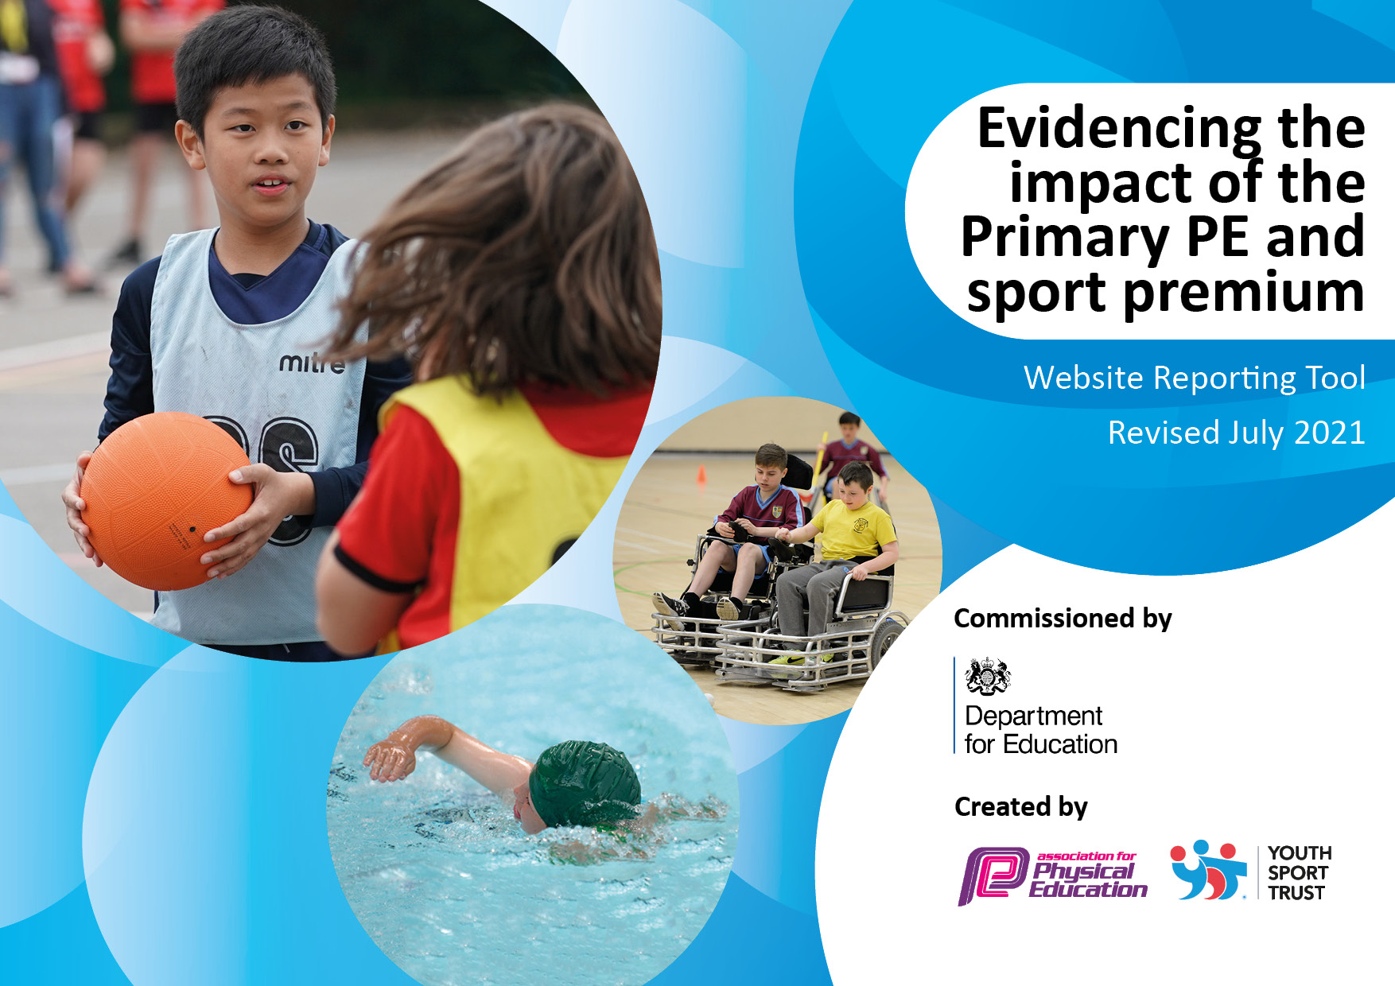
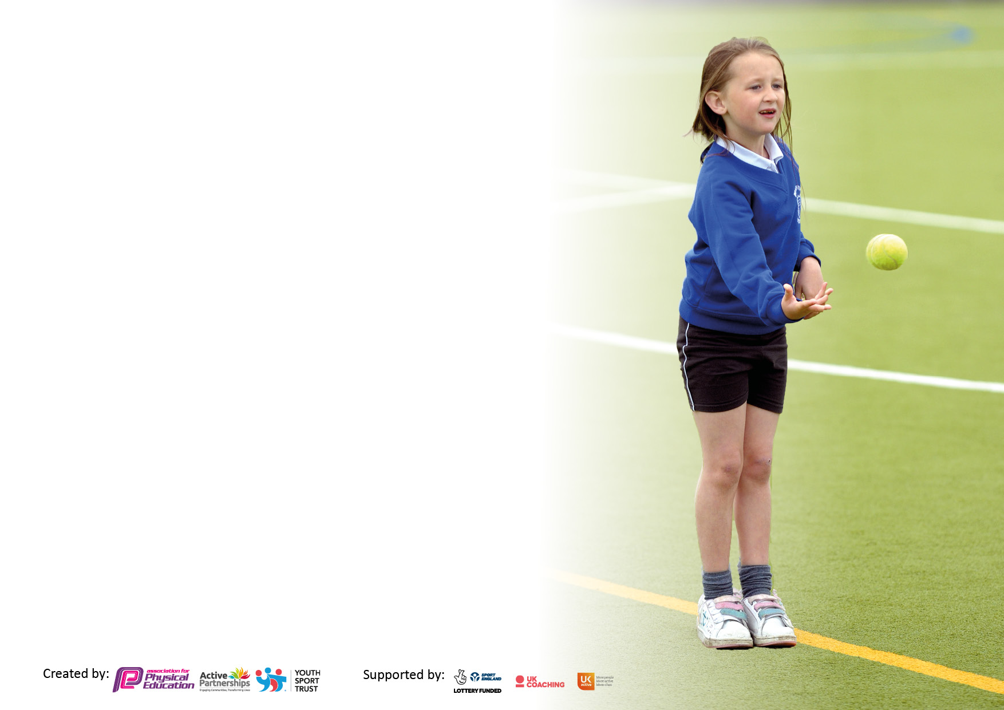

It is important that your grant is used effectively and based on school need. The Education Inspection Framework makes clear there will be a focus on ‘whether leaders and those responsible for governors all understand their respective roles and perform these in a way that enhances the effectiveness of the school’.

Under the Quality of Education Ofsted inspectors consider:
Intent - Curriculum design, coverage and appropriateness
Implementation - Curriculum delivery, Teaching (pedagogy) and Assessment
Impact - Attainment and progress

To assist schools with common transferable language this template has been developed to utilise the same three headings which should make your plans easily transferable between working documents.

Schools must use the funding to make additional and sustainable improvements to the quality of Physical Education, School Sport and Physical Activity (PESSPA) they offer. This means that you should use the Primary PE and sport premium to:

- Develop or add to the PESSPA activities that your school already offer
- Build capacity and capability within the school to ensure that improvements made now will benefit pupils joining the school in future years
- The Primary PE and sport premium should not be used to fund capital spend projects; the school’s budget should fund these.

Pleasevisitgov.ukfortherevisedDfEguidanceincludingthe5keyindicatorsacrosswhichschoolsshoulddemonstrate animprovement.Thisdocumentwillhelpyoutoreviewyourprovisionandtoreportyourspend.DfEencouragesschools to use this template as an effective way of meeting the reporting requirements of the Primary PE and sport premium.

We recommend you start by reflecting on the impact of current provision and reviewing the previous spend.

Schools are required to publish details of how they spend this funding, including any under-spend from 2019/2020, as well as on the impact it has on pupils’ PE and sport participation and attainment. All funding must be spent by 31st July 2022.

We recommend regularly updating the table and publishing it on your website throughout the year. This evidences your ongoing self-evaluation of how you are using the funding to secure maximum, sustainable impact. Final copy must be posted on your website by the end of the academic year and no later than the 31st July 2021. To see an example of how to complete the table please click HERE.
Created by: Supported by:

Details with regard to funding
Please complete the table below.

Total amount carried over from 2021/22 | £0
Total amount allocated for 2021/22 | £18,680
How much (if any) do you intend to carry over from this total fund into 2022/23? | £0
Total amount allocated for 2022/23 | £18,890
Total amount of funding for 2022/23. To be spent and reported on by 31st July 2023. | £18,890
Swimming Data
Please report on your Swimming Data below.

Meeting national curriculum requirements for swimming and water safety.

N.B. Complete this section to your best ability. For example you might have practised safe self-rescue techniques on dry land which you can then transfer to the pool when school swimming restarts.
Due to exceptional circumstances priority should be given to ensuring that pupils can perform safe self rescue even if they do not fully meet the first two requirements of the NC programme of study
What percentage of your current Year 6 cohort swim competently, confidently and proficiently over a distance of at least 25 metres?  N.B. Even though your pupils may swim in another year please report on their attainment on leaving primary school at the end of the summer term 2021.  Please see note above | 21%
What percentage of your current Year 6 cohort use a range of strokes effectively [for example, front crawl, backstroke and breaststroke]?  Please see note above | 21%
What percentage of your current Year 6 cohort perform safe self-rescue in different water-based situations? | 100%
Schools can choose to use the Primary PE and sport premium to provide additional provision for swimming but this must be for activity over and above the national curriculum requirements. Have you used it in this way? | Yes

Action Plan and Budget Tracking
Capture your intended annual spend against the 5 key indicators. Clarify the success criteria and evidence of impact that you intend to measure to evaluate for pupils today and for the future.

Academic Year: 2022/23 | Total fund allocated: £18,890 | Date Updated: November 2022
Key indicator 1: The engagement of all pupils in regular physical activity – Chief Medical Officers guidelines recommend that primary school pupils undertake at least 30 minutes of physical activity a day in school |  |  |  | Percentage of total allocation:
 |  |  |  | % £9,930
Intent | Implementation |  | Impact
Your school focus should be clear what you want the pupils to know and be able to do and about  what they need to learn and to  consolidate through practice: | Make sure your actions to achieve are linked to your intentions: | Funding allocated: | Evidence of impact: what do pupils now know and what can they now do? What has changed?: | Sustainability and suggested next steps:
Children have access to further physical activities on and off site. A structured programme of activities is completed. Increased physical activity and well-being. | Daily clubs programme in place -including new clubs/sports.  - 2 hours of quality PE provision including a dance session in the dance studio weekly. Employment of Dance teacher  - GetSetPE 12-month registration – early years – Year 6  - New opportunities e.g. sports not tried before e.g. Tai chi/ Yoga/ golf and bmx. To encourage pupils to continue these sports through clubs  Foster a love for Sport in Early Years/KS1 that continues throughout the school (through clubs and opportunities).  - Half Termly opportunities for whole school e.g. father Christmas run, bunny run, Hawaiian run  - Balanceability introduced in Reception and continued use of bikes weekly  - Wake and shake before school regularly  - Plan an enrichment week with a sport focus. Have a visitor that competes in sport. Providing a range of provision.  - Sports leaders completing activities daily  -Continuation of Sensory Circuits  -Membership to Forest Heath Primary Schools’ Sport Association | £2,000  £2,780  £500  £2,000  £500  £500  £500  £1,000  £150 | A variety of clubs have been provided for children at lunch times and after school. Sports such a rounders, athletics, basketball, hula hoops and football are examples.  Children received this provision each week. LE delivering half the PE curriculum for each class. 1 session a week during teacher PPA.  This was implemented successfully. Teacher use scheme to deliver lessons weekly.  All classes in the school will take part it a golf day on Friday 14th July.  EYFS have completed the 6 week balanceability course during the summer term.  There have been opportunities for KS1 to attend clubs after school such as althetics and rounders.  EYFS have completed the 6 week balanceability course during the summer term.  Children took part in wake and shake during the autumn term.  We had a BMX whole school assembly and year 6 workshop in November.  Sports leaders trained by academy leaders for sports day. They delivered Sports day.  Apex have completed sensory circuits.  Pe lead attended training within membership (SEND workshop and networking day)  As a school we have taken part in multiple competitions and festivals. We have completed a whole school virtual cross country and virtual dance festival. KS2 have had multiple opportunities to take part in sports events. For example Multi sports festival, rugby skills festival and indoor athletics. | GetSet4PE provide plans for all teachers, especially those with less confidence/ experience. Teachers feel more confident in ability to teach PE.  EYFS developed agility, balance and coordination skills during this course.  EYFS developed agility, balance and coordination skills during this course.  Sports leaders taking ownership of leading and gaining confidence.  PE has developed knowledge to deliver back to staff to make lessons more inclusive.  Children have taken part in a variety of sports, it has encouraged participation in a variety of sports. It has built children confidence and communication skills.
Key indicator 2: The profile of PESSPA being raised across the school as a tool for whole school improvement |  |  |  | Percentage of total allocation:
 |  |  |  | % £8,520
Intent | Implementation |  | Impact
Your school focus should be clear what you want the pupils to know and be able to do and about  what they need to learn and to  consolidate through practice: | Make sure your actions to achieve are linked to your intentions: | Funding allocated: | Evidence of impact: what do pupils now know and what can they now do? What has changed?: | Sustainability and suggested next steps:
Children’s mental health, well-being, self-esteem, confidence and co-operation will be raised. (SDP 8) Ready for life curriculum | Workshops  - Balanceability  - Bikeability for Year 6  - Forest schools (whole school) To develop physical activity/wellbeing outdoors  -2 minute daily fitness challenge  - Continuation of playpods to improve behaviour, cooperation and fitness levels  - Wake and shake  - Regular mile activities – themed egg race, father Christmas run etc  - Subject release time to plan and lead this | Already stated in this document  Already accounted for previously in this document (£500)  £500  £2,340 a term. Total: £7,020  £500  £500 | Children took part in wake and shake during the autumn term. Apex have completed sensory circuits.  During mental health week in February children took part in a range of physical activities.  EYFS have completed the 6 week balanceability course during the summer term.  Year 6 will be completing bikeability course during the summer term.  Forest School sessions completed by all years throughout the academic year. Sessions were lead by a specialist.  Year 6 summer camp in summer term. Children building fires and taking part in team building activities.  Autumn challenges in each class.  Each class running fortnightly personal challenge boards aimed to push personal bests in new activities.  The playpod has continued to be topped up with new resources regularly.  Children took part in wake and shake during the autumn term.  The whole school completed a virtual cross country challenge during Autumn term.  PE lead has been given some release time. | Children have engaged well completed fun ways to get more active.  EYFS developed agility, balance and coordination skills during this course.  Bikeabilty builds life skills and develops children confidence on the roads. They learn about road safety.  Staff have improved knowledge on forest school environment and activities to complete. Children have also developed skills.  Children were enthusiastic and engaged to improve and push themselves.  The playpod has encouraged creative play, improved cooperation and some behaviours.

Key indicator 3: Increased confidence, knowledge and skills of all staff in teaching PE and sport |  |  |  | Percentage of total allocation:
 |  |  |  | % £1500 (rest already stated in other sections)
Intent | Implementation |  | Impact
Your school focus should be clear | Make sure your actions to | Funding | Evidence of impact: what do | Sustainability and suggested
what you want the pupils to know | achieve are linked to your | allocated: | pupils now know and what | next steps:
and be able to do and about | intentions: |  | can they now do? What has
what they need to learn and to |  |  | changed?:
consolidate through practice:
Staff must be upskilled and pupils have the best experiences in PE possible. Lessons all good or outstanding. | Various inset/courses/Athletics/Gymnastics  - Workshops/staff meetings to upskill staff  - Weekly dance sessions in the studio  - Release time for subject leaders to work with individual staff members  -Yoga Schools Training and Scheme of work | £1000  As already stated  As already stated (£2,780)  As already stated  £500 | Pe lead attended training within membership (SEND workshop and networking day)  Staff meeting delivered in summer term.  Dance session were completed in autumn and spring term with LE.  PE lead has given some time to do learning walks and observations. Feedback given to teachers after observations.  Cosmic yoga has been used in sessions for PE. | Pe lead sharing knowledge in staff meeting. Looking at how to scaffold/ adapt for SEN children.  Pe lead sharing what a good PE looks like and what to include, ensuring consistency within school using Getset4PE scheme.  Pe lead and teachers working together to improve aspects of PE.
Key indicator 4: Broader experience of a range of sports and activities offered to all pupils |  |  |  | Percentage of total allocation:
 |  |  |  | Already stated in other sections
Intent | Implementation |  | Impact
Your school focus should be clear | Make sure your actions to | Funding | Evidence of impact: what do | Sustainability and suggested
what you want the pupils to know | achieve are linked to your | allocated: | pupils now know and what | next steps:
and be able to do and about | intentions: |  | can they now do? What has
what they need to learn and to |  |  | changed?:
consolidate through practice:
Additional achievements:  More pupils will be physically active regularly | Plan an enrichment week with a sport focus. Have a visitor that competes in sport. Providing a range of provision.  - Range of clubs for all year groups to be available daily  - Wake and shake  Day workshops where expertise is shared and continued eg Yoga, Tai chi, Mindfulness.  - Balanceability offered to Reception and bike sessions continued after  -Bikeabiity offered in Year 6  - Subject leader release time to organise this  -Implement Sensory Circuit | All funding in this section already accounted for in previous sections  (£2,000)  (£500)  (£500)  (£1000) | There have been a wide range of clubs available for all year groups. Teachers deliver lunchtime PE clubs such as hula hoops, basketball, football, games and skipping.  Children took part in wake and shake during the autumn term.  We had a BMX whole school assembly and year 6 workshop in November.  EYFS have completed the 6 week balanceability course during the summer term.  Year 6 will be completing bikeability course during the summer term.  Time given to subject leader to organise opportunities for children to be active regularly | Children have clubs available to choose from.

Key indicator 5: Increased participation in competitive sport |  |  |  | Percentage of total allocation:
 |  |  |  | % £1500
Intent | Implementation |  | Impact
Your school focus should be clear | Make sure your actions to | Funding | Evidence of impact: what do | Sustainability and suggested
what you want the pupils to know | achieve are linked to your | allocated: | pupils now know and what | next steps:
and be able to do and about | intentions: |  | can they now do? What has
what they need to learn and to |  |  | changed?:
consolidate through practice:
The number of children who take part in competitive sports has increased. Opportunity for children to take part in competitions in different sports. | - Employ Ian Jackson to plan competitions  - Continue to take opportunities for children to take part in competitive sport/sport for fun (see calendar of events -Newmarket pyramid. Opportunities provided by Forest Heath Primary Schools’ Sport Association).  - Enter classes into competitive  competitions over the year.  - Revamped sports day  - Themed runs including Father Christmas run and egg race at Easter  - Complete Schools game mark and aim for Gold. | £150 (already stated in this document)  Taxi costs & staff release £1000  Release time £500 for all of these things | Ian Jackson has planned and delivered a variety of competitions. As a school we have taken part in multiple competitions and festivals. We have completed a whole school virtual cross country and virtual dance festival. KS2 have had multiple opportunities to take part in sports events. For example, Multi sports festival, rugby skills festival and indoor athletics. They have also taken part in U11 cross country competition.  KS2 have been to the competitions over the academic year.  Sports day held of 17th July. Sports day modified to avoid boys and girls gender specific races.  School games mark application  Application completed with Ian Jackson. | Children have participated in a range of competitions and festivals, increasing their confidence. They have competing and worked alongside other schools/ children increasing their communication skills.

Signed off by
Head Teacher: | L Tweed
Date: | 7/11/22
Subject Leader: | Rachel Hogg
Date: | 7/11/22
Governor: | Alistair Paterson
Date: | 7/11/22

