Houldsworth Valley Primary Academy Lockdown Procedures
All policies are underpinned by our child protection procedures as laid down by the child protection policy.
Lockdown procedures should be seen as a sensible and proportionate response to any external or internal incident which has the potential to pose a threat to the safety of staff and pupils in the school. Procedures should aim to minimise disruption to the learning environment whilst ensuring the safety of all pupils and staff.
Lockdown procedures may be activated in response to any number of situations, but some of the more typical might be:
• A reported incident/ civil disturbance in the local community (with the potential to pose a risk to staff and pupils in the school)
• An intruder on the school site (with the potential to pose a risk to staff and pupils)
• A warning being received regarding a risk locally of air pollution (smoke plume, gas cloud etc)
• A major fire in the vicinity of the school
• The close proximity of a dangerous dog/animal roaming loose
The school’s lockdown plan is as follows:
Signals
Signal for lockdown Teams Message to all staff
Signal for all-clear Verbal confirmation – teams or in person
Lockdown
All classes to remain in own classroom
Entrance points (e.g. doors, windows) should be secured - External doors, Fire doors, Internal doors, all windows.
Communication arrangements – Teams or mobile phones
If someone is taken hostage on the premises, the school should seek to evacuate the rest of the site
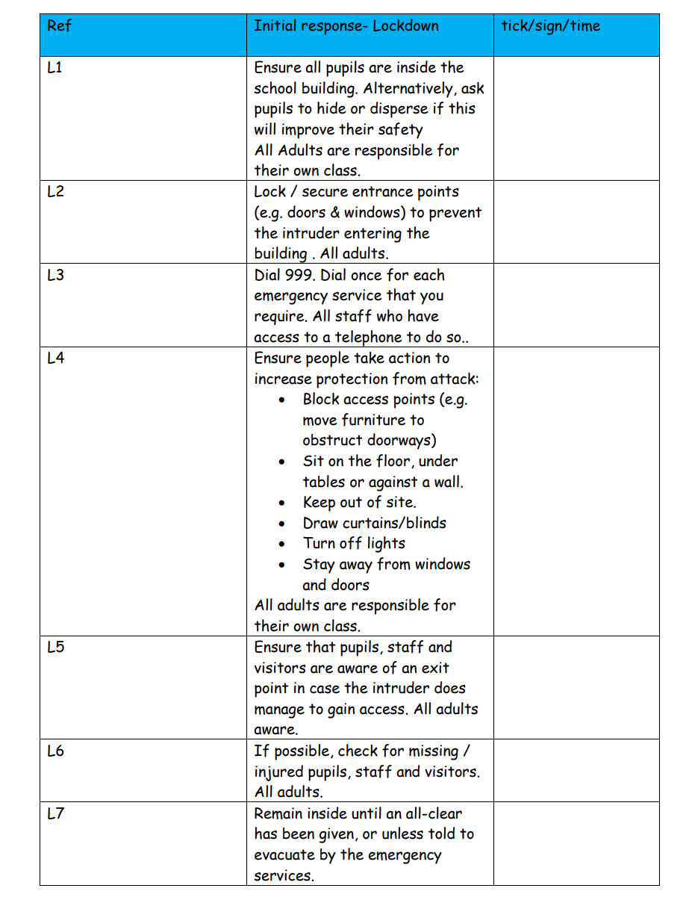
- Pupils who are outside of the school buildings are brought inside as quickly as possible, unless this endangers them or others. If children remain outside they will moved to the nearest place of safety on or off site.
• Those inside the school should remain in their classrooms.
• All external doors and, as necessary, windows are locked (depending on the circumstances, internal classroom doors may also need to be blocked)
• Once in lockdown mode, staff should notify the office immediately on teams of any pupils not accounted for via telephone (mobiles to be used if teams is not available) and instigate an immediate search for anyone missing if safe to do so.
• Staff should encourage the pupils to keep calm.
• As appropriate, communication with the Emergency Services will be established and the Executive Headteacher contacted if off-site
• Parents will be notified as soon as it is practicable to do so via parentmail
• Pupils will not be released to parents during a lockdown
• If it is necessary to evacuate the building, the fire alarm will be sounded and everyone should leave the building via the nearest exit and assemble on Newmarket Academy’s field.
Partial Lockdown
Alert to staff: “Partial lockdown”
This may be as a result of a reported incident / civil disturbance in the local community with the potential to pose a risk to staff and pupils in the school. It may also be as a result of a warning being received regarding the risk of air pollution, etc.
Immediate action:
• All outside activity to cease immediately, pupil and staff to return to the building. (Staff will be alerted via teams and verbal communication.)
• All staff and pupils remain in the building and external doors and windows locked
• Movement may be permitted within the building dependent upon circumstances but this must be supervised by a member of staff
All situations are different, once all staff and pupils are safely inside, senior staff will conduct an on-going any dynamic risk assessment based on advice from the Emergency Services. This can then be communicated to staff and pupils on teams
“Partial lockdown” is a precautionary measure but puts the school in a state of readiness (whilst retaining a degree of normality) should the situation escalate. Emergency Services will advise as to the best course of action in respect of the prevailing threat
Full Lockdown
Alert to staff: “Full lockdown”
This signifies an immediate threat to the school and may be an escalation of a partial lockdown.
Immediate action:
• All pupils to return to classroom
• External doors locked. Classroom doors locked and blocked
• Windows locked, blinds drawn, pupils sit quietly out of sight under desks.
• Register taken/head count- the office will contact each class in turn for an attendance report via teams
• Staff and pupils remain in lock down until it has been lifted by a senior member of staff / emergency services.
• At any point during the lockdown, the fire alarm may sound, and a message via teams sent which is a cue to evacuate the building and go to the Newmarket Academy field.
• During lockdown, staff will keep agreed lines of communication open, via teams, but will not make unnecessary calls to the office as this could delay more important communication
Communication between parents and the school
In the event of an actual lockdown, any incident or development will be communicated to parents as soon as is practicable.
Parents will be given enough information about what will happen so that they :
• Are reassured that the school understand their concern for their child’s welfare, and that it is doing everything possible to ensure his/her safety
• Do not need to contact the school. Calling the school could tie up telephone lines that are needed for contacting emergency providers
• Do not come to the school. They could interfere with emergency provider’s access to the school and may even put themselves and others in danger
• Wait for the school to contact them about when it is safe for you to come and collect their children, and where this will be from. Parents will be told “ …the school is in a full lockdown situation. During this period external doors locked and nobody allowed in or out…”
Emergency Services
It is important to keep lines of communication open with Emergency Services as they are best placed to offer advice as a situation unfolds. The school site may or may not be cordoned off by Emergency Services depending on the severity of the incident that has triggered the lockdown.
Emergency Services will support the decision of the Headteacher with regarding the timing of communication to parents.

Lisa Tweed September 2022

